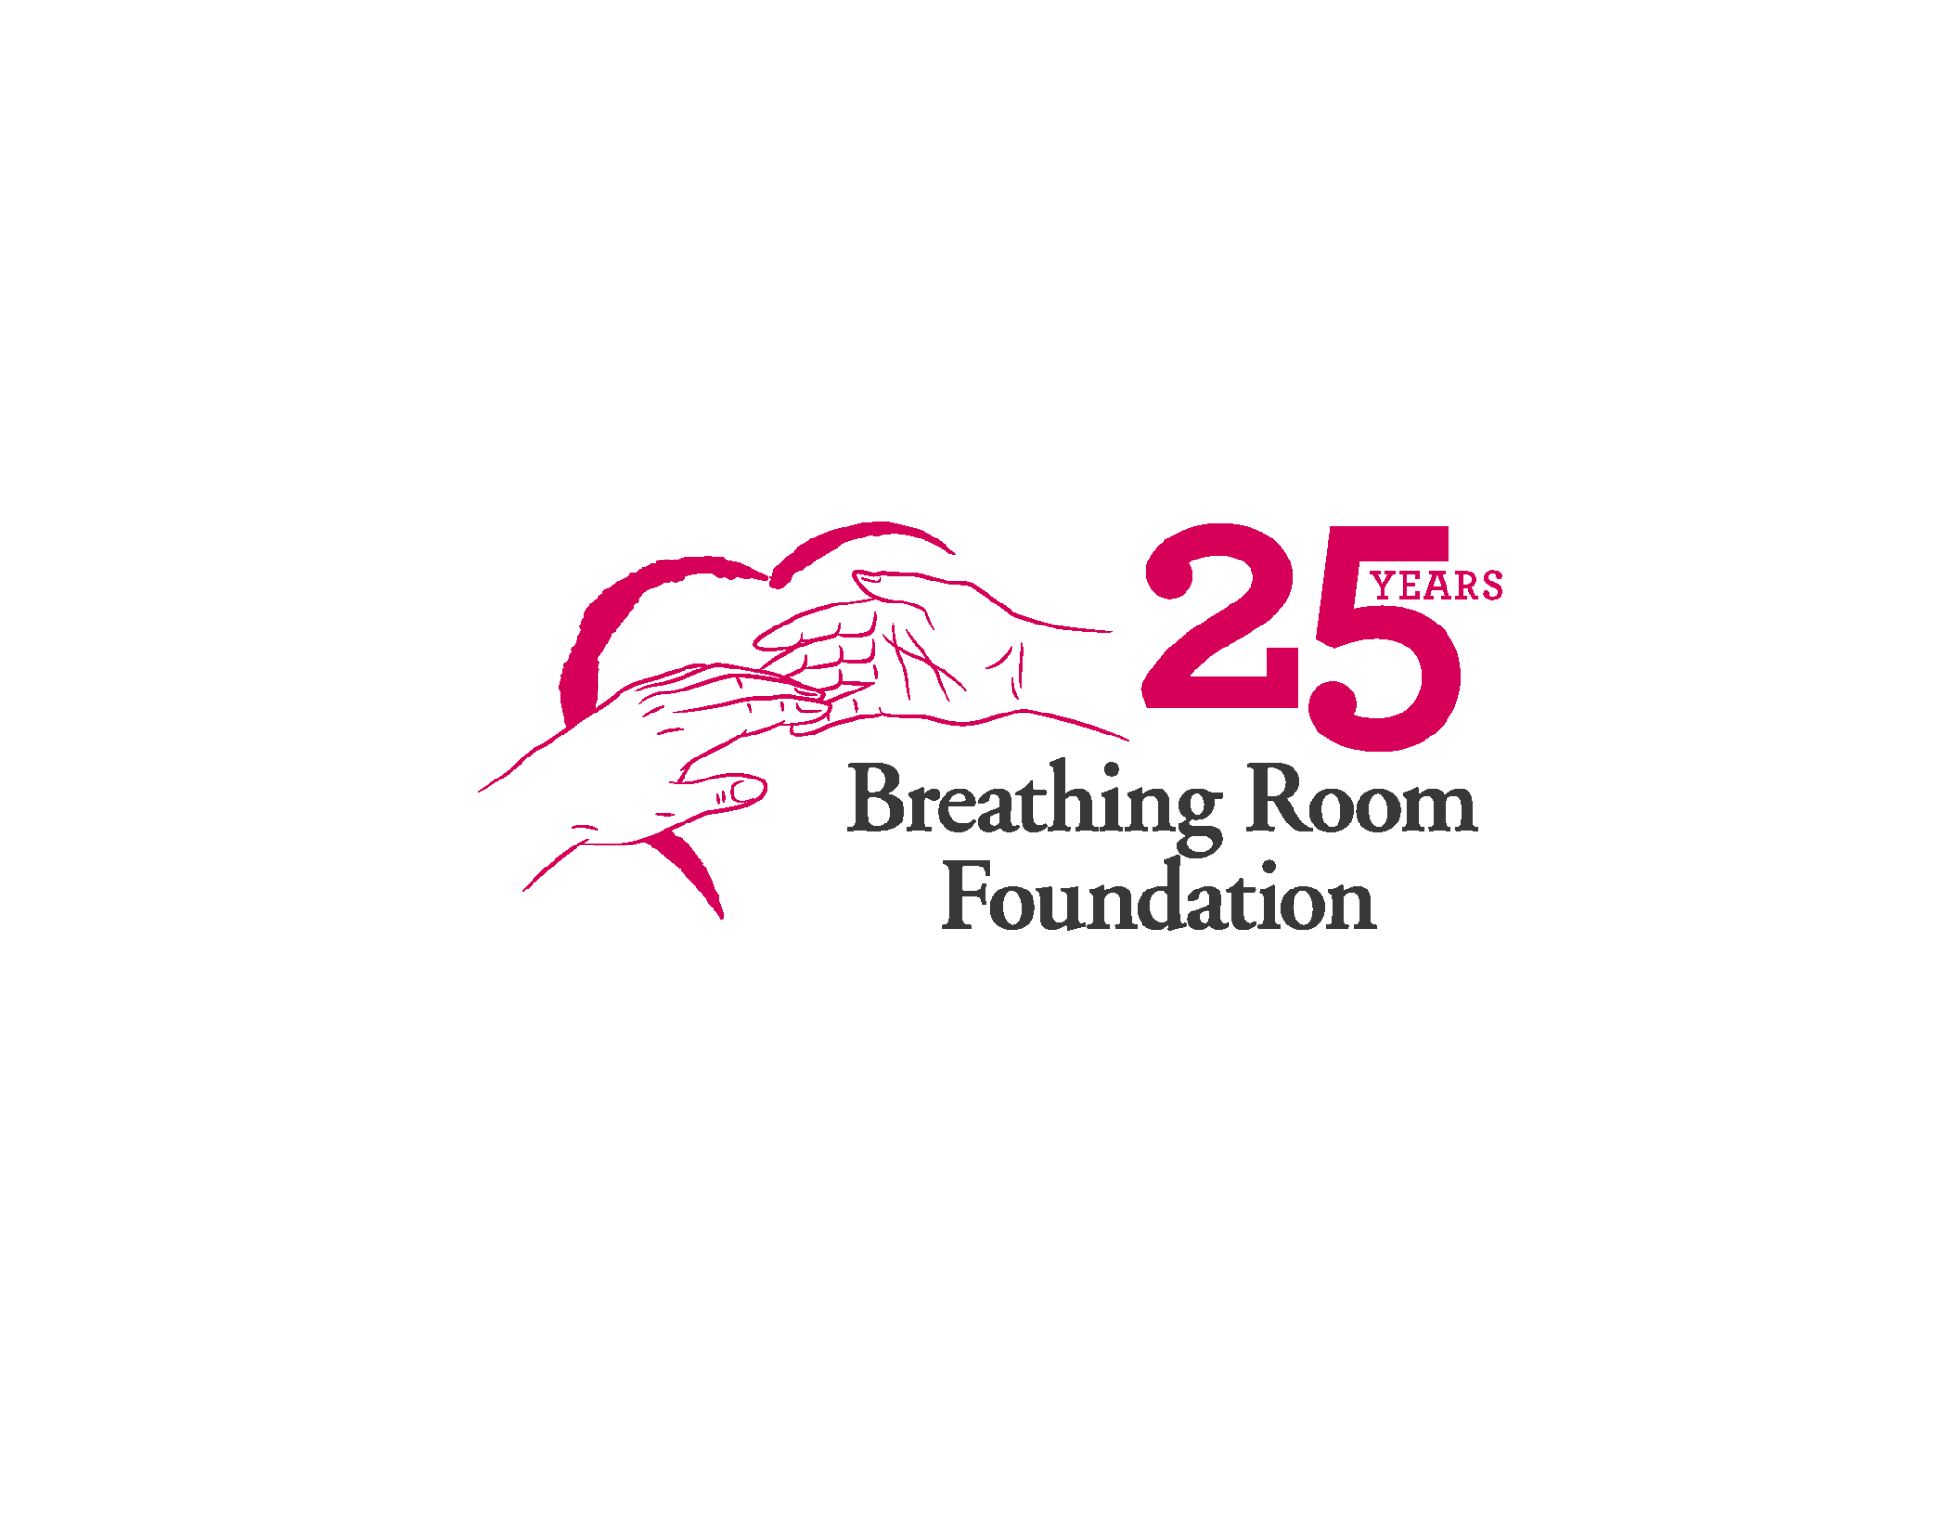

**Thank you** for your generous offer to participate in the Breathing Room Foundation (BRF) Holiday Program. BRF is a local organization that provides care and support to families who are facing a cancer diagnosis. Our service area includes all of Philadelphia and parts of Montgomery, Bucks, Delaware and Chester Counties. Below are details to guide you as you plan your shopping or organize your family, friends or co-workers’ contributions to provide the family/individual a memorable holiday.

**Shopping:** You will be provided with a Holiday Wish List completed by the family/individual you are sponsoring. Use this as a guideline to choose gifts that are appropriate. Feel free to use your imagination as you would when purchasing for your own friends or family.

**Gift Cards:** Always a good option, especially for teens and adults.

**Wrapping:** Wrapping the gifts is optional but encouraged. Gifts must be wrapped before delivery to the family, however we do have wrapping volunteers at the office throughout this program. Feel free to bring the gifts unwrapped if your time is limited. When bringing the gifts wrapped, we ask that you **include a list of what is included for each person**. This allows us to add a missing item if we have it at the office from other donations that have been received. Please be sure to use appropriate wrap. If the family is listed as celebrating a holiday other than Christmas, please use a plain or winter wrap.

**Gift Tags:** Each gift should have a tag on it with the gift recipient’s name in the “To” and with the “From” left blank. We do this so that the parent can then fill in what is appropriate for their traditions.

**Drop-off:** We ask that you clearly mark each bag/box of gifts with the family’s name when you drop-off to BRF so that if they get separated at the office, we can easily identify them. Please be sure to check in with someone so that we can mark the gifts as received and put them in their appropriate location for delivery.   
  
**Our office address is:  
8310 Brookside Road (Come around to the back of the building for drop-off)  
Elkins Park, PA 19027  
215-277-1006 or 215-570-0530 (my cell)**  
**Deadline: (Thursday, December 12th)**  If by chance you are unable to make the drop off deadline, please let me know by phone or email. This way we can keep the family informed as to when they will receive their delivery.

**Delivery directly to the family:** Often this can be an option. Please let me know if you wish to do this so that we can try to make these arrangements. If you are delivering to the family, please be sure that gifts are wrapped and tagged as requested above and put in dark trash bags for delivery so that if children see the gifts, they aren’t able to see the surprises inside. Please keep me informed of the delivery plan once arranged with the family. Please make every attempt to deliver, or at the very least contact the family prior to December 15th. We ask that you limit the number of people making the delivery and be respectful of the families privacy and their health.  
  
**Unable to fulfill a wish list?** No worries! Just make us aware and we will be sure to supplement so that the family is well cared for. We want this to be a positive experience for all, not a stressful one.   
  
**Privacy:**  Please respect the privacy of the family and do not share the family’s contact information with others.

Thank you for your kindness and generosity toward BRF’s Holiday program. We couldn’t do this without all of you! Your support provides our families a little “breathing room” during the holidays. Please do not hesitate to contact me with any questions or concerns. **Email:** [**maryellen@breathingroomfoundation.org**](mailto:maryellen@breathingroomfoundation.org)

To learn more about the Breathing Room Foundation go to [**www.breathingroomfoundation.org**](http://www.breathingroomfoundation.org)